AS91076 and AS91075
“Construct and Implement a plan to program a Minecraft Agent to complete a basic task”
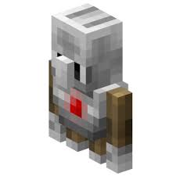
Name: Greg
Student Number: 314171
Learning Leader: Mr Smirk
Due Date: 29/11/2017

Table of Contents

AS91076 and AS91075 “Construct and Implement a plan to program a Minecraft Agent to complete a basic task”
Table of Contents
Project Brief
Planning and Implementation
Variables:
Plan
Coding
Testing .

Project Brief

Please insert your brief statement in the following box
The task that my agent will undertake is to measure the distance between one wall and another

Planning and Implementation

Variables:

Please insert the variables you are using for your program here.

VariableName | Type | Purpose
dist | Number | To store the total distance between
go | Boolean | Let’s the while loop know if the end has been reached

Plan
This Section needs to be completed independently in order to get Merit or higher
Please use Google Draw to construct a flowchart that displays your programming plan

On chat command “run”
Call the function “doTeleportAgentToPlayer”
Say to screen “Agent is ready to start measuring”
Set go to true
Set dist to 0
Comment: go is a Boolean variable, dist is a number variable
While go is true do
If Agent detects a block in front of it then
Set go to false
Comment: terminates the While loop
End
Agent moves forward by 1
Change dist by 1
Comment: calculates the distance to wall
End
Say “Agent has finished measuring”
Say “The distance is:” dist
Comment: displays the distance to the wall
End

Function doTeleportAgentToPlayer
Teleport the Agent to the player
End

Coding
This Section needs to be completed independently in order to get Merit or higher.
Please paste your program code with comments here:

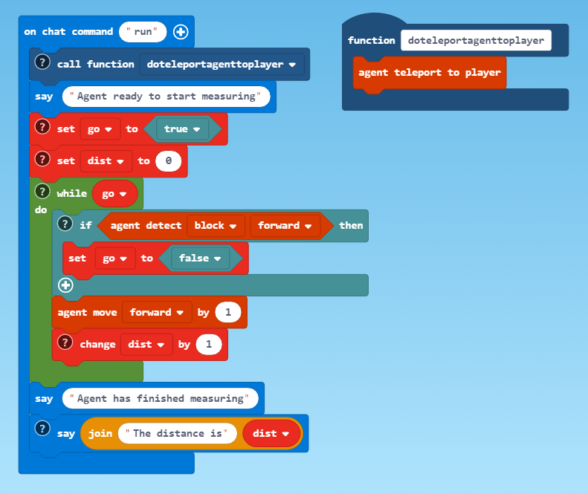

? comment: calls a function to teleport the agent to the player
? comment: go is a Boolean variable used to terminate the while loop when the agent detects a block in front of it.
? comment: dist is a number variable used to record the distance to the wall
Etc.

Testing
.
Create a table here showing how you are going to test your application

Test Scenario | Expected input and output | What actually happened | What need to be fixed
Testing that the agent will stop when it hits a wall | agent goes forward until it hits into a wall | agent stopped in its tracks and didn’t move forward | Change true to false in while statement
Does the agent measure distance correctly | Agent finds wall | Distance is displayed | Worked dist was displayed as 3. I measured it as 3.
Etc.

Test Scenario | Boundary Input | What actually happened | What need to be fixed
A cow or other animal is in the agent’s way | There is not a clear run to the wall | Agent when through the animal | No fix needed

Test Scenario | Invalid Input | What actually happened | What need to be fixed
The agent is in a flat world | There is no wall | Agent went on and on until stopped | Nothing this was expected but the user should know how to stop the program

