AS91075/AS91076

“Construct a plan to program a Minecraft Agent to complete a basic task”

“Construct a basic computer program for a specified task”
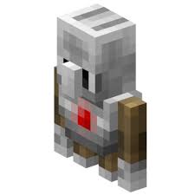
Name:
Student Number:
Learning Leader:
Due Date:

Project Brief

Please insert your brief statement in the following box

Planning and Implementation

Variables:

Please insert the variables you are using for your program here.
(Ensure that you have two different types)

Variable Name | Type | Purpose

Plan
This section needs to be completed independently in order to get Merit or Higher.
Please use Pseudocode to construct a plan that displays your programming

Main program

Functions (optional)

Coding
This Section needs to be completed independently in order to get Merit or higher.
Please paste your program code with comments here:

Testing
Fill in this table here showing how you are going to test your application, then use it to test your program. ACHIEVED IS RED, YELLOW IS MERIT, GREEN IS EXCELLENCE

Test Scenario | Expected input and output

Test Scenario | Boundary Input and expected output  (e.g. what happens if you enter 0 or 1,000 or just at the edge of the boundary)

Test Scenario | Invalid Input and expected output(if the learner enters a word instead of a number)

