Pseudocode is everyday language used to describe what needs to happen in a computer program.
For example
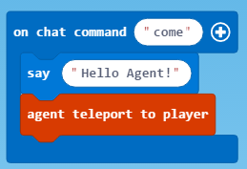
This MakeCode could be described in everyday language by saying:
Start block
When the chat command “come” is entered
Say “Hello Agent!”
Teleport the agent to the player
End block

Make a Crop Farm

TASK
Write pseudocode for this crop farm:
Let’s assume you can load your seeds into your agent’s inventory.
- One type of crop - 16 blocks total area
- The blocks should be planted in a square area

Write your pseudocode in this box.

Take screen shots of your MakeCode once you get it working.

Also include a screen shot of the planted crop.

